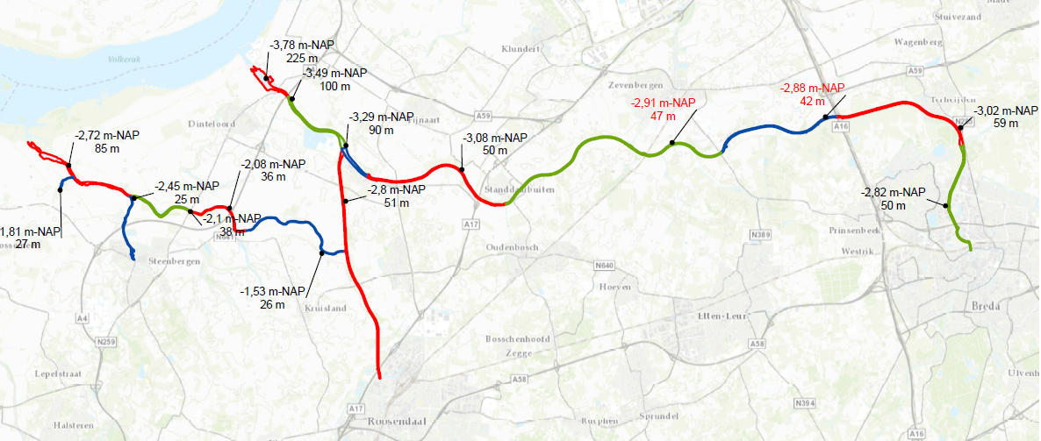

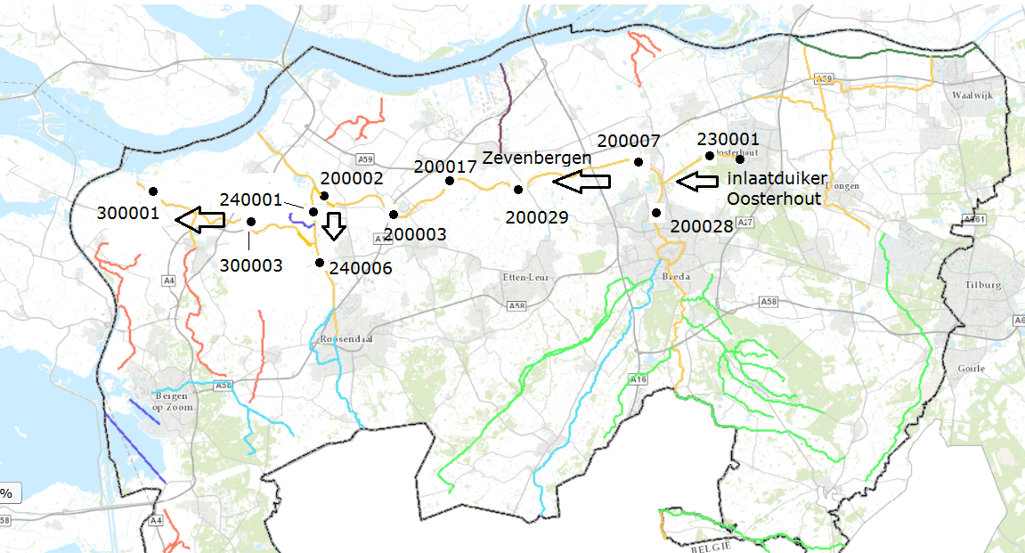

Figure 1: Mark-Vliet bosom profile

# Water & P balance

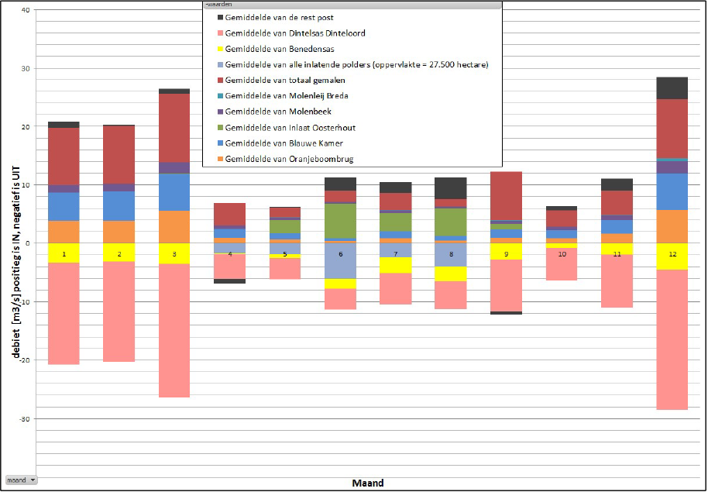

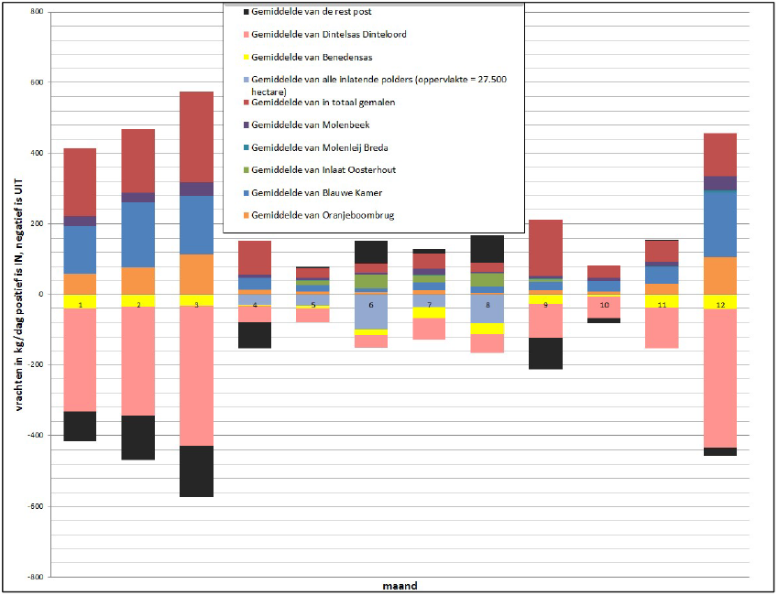

Figure 6: The monthly average water balance and phosphorus (P) loads for the Mark-Dintel-Vliet system in the year 2017. Gemiddelde van de rest post- Average of the rest heading; Gemiddelde van Dintelsas Dintel - Average of Dintelsas Dintel; Gemiddelde van Benedensas - Average of Down Vliet; Gemiddelde van alle inlatende polders (opperlakte = 27500 hectare) - Average of all inlet polders (surface area = 27500 hectares); Gemiddelde van totaal gemalen - Average of total ground; Gemiddelde van molenleij breda - Average of Molenleij Breda; Gemiddelde van molenbeek - Average of gastel; Gemiddelde van inlaat oosterhout - Average of inlet oosterhout; Blauwe Kamer & Oranjeboombrug upstream of Breda.

Table 4: Annual phosphorus load of water body Mark-Dintel-Vliet from the source analysis by Schipper et al., 2018.

|  |  |
| --- | --- |
| **Source** | **P IN (%)** |
| Belgium | 38.5% |
| Netherlands | 61.5% |
| **Subdivision of Dutch P sources** |  |
| * Washing and washing off | 39% |
| * Topical fertilization | 8% |
| * Historical fertilization | 4% |
| * Subsequent delivery of the bottom | 2% |
| * Wash-out and run-off from natural soils | 2% |
| **Other** | 22.5% |
| * Agriculture other | 5% |
| * WWTPs | 0% |
| * Overflowing | 1% |
| * Other anthropogenic (domestic waste water, ibas, shipping, avi, etc.) | 2% |
| * Atmospheric deposition on open water | 0% |
| * Inlet water Wilhelminkanal | 6.1% |
| * WWTPs shifting upstream | 0.1% |
| * Other shifting upstream | 8.4% |

Appendix 5: calculation of the inlet direction polders



Klaas-Jan Douben calculated for 5 strands of the model what the inlet is towards polders in a 10% dry year (see Corsa 15IN034195). These are the (pink) columns 2 to 6). Column 7 is the total flow rate admitted. These figures apply to a 10% dry year, but not necessarily for the (calculated year 2010).

Column 8 shows the total inlet flow (residual item) as I calculated for the period that the model is running. In column 9, the quotient of becomes column 8 and column 7. The numbers in column 9 are the factor by which you have to multiply the “general” inlet flow rates (columns 2 to 6) to obtain the inlet flow rates in 2010. These flow rates are calculated in columns 10 to 14.

• Column 10 (yellow) is the water that is let in between the “tram bridge” (end of the Breda canals) and the point where the Markkanaal flows into the Dintel. This inlet flow is subtracted in the model from the flow at “tram bridge”.

• Column 11 (green) is the water that is introduced into the polders between the point where the Mark Canal flows into the Dintel and the junction of the Dintel with the Mark-Vliet Canal. This inlet flow in the model in this portion of the strand gradually disappears from the modeled strand.

• Column 12 (blue) is the water that is let into the strand to Dintelsas. This strand is not modeled. In the water, this flow rate is added to the water that goes out at Dintelsas. After all, the model concerns the water that “disappears” from the model when it splits with the Mark-Vliet canal. This is then the sum of the water that is introduced into the (non-modeled) strand towards Dintelsas and the discharge at Dintelsas itself.

• Column 13 (green) is the water that is let into the polders between the junction of the Dintel with the Mark-Vlietkanaal and the Bovensas lock. This inlet flow in the model in this portion of the strand gradually disappears from the modeled strand.

• Column 14 (orange) is the water that is let into the polders between the Bovensas lock and the Benedensas lock. For 2010, only flow rates from Bovensas were known, not Benedensas. This water (orange column) is therefore added to the flow rate of Bovensas. In the model, it is gradually added to the modeled strand.

Validation:

Chl_a: PCLake using Qin, Qout and PLoad from 2017; Measurement from 2010

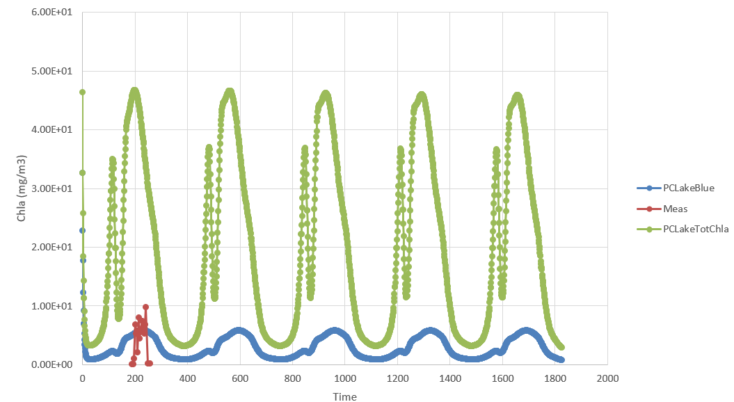

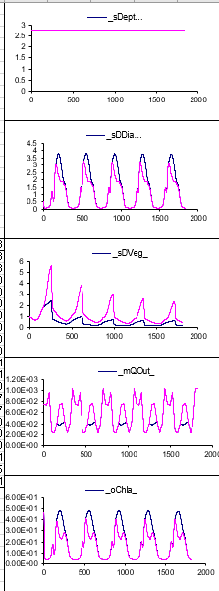 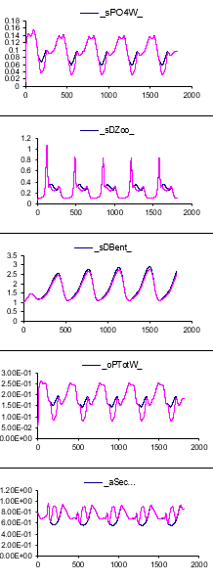 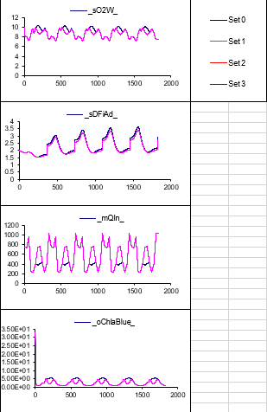

Set 0: Current discharge (Q)

Set 0: Current discharge + 10 m3/s (Q+10)

Average of July and August:

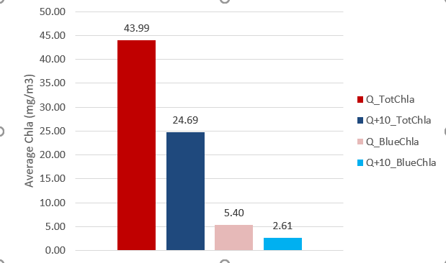

River model simulation

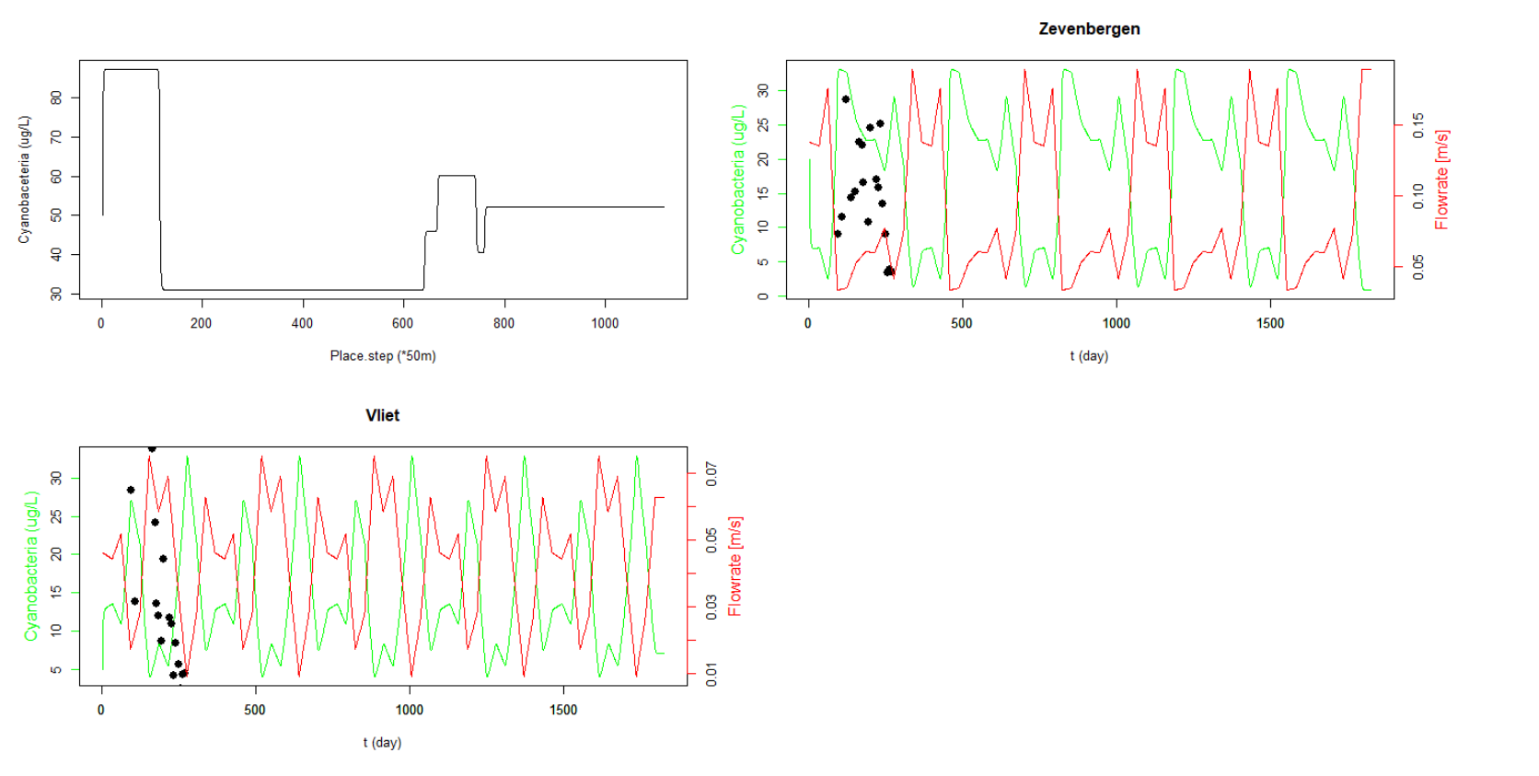

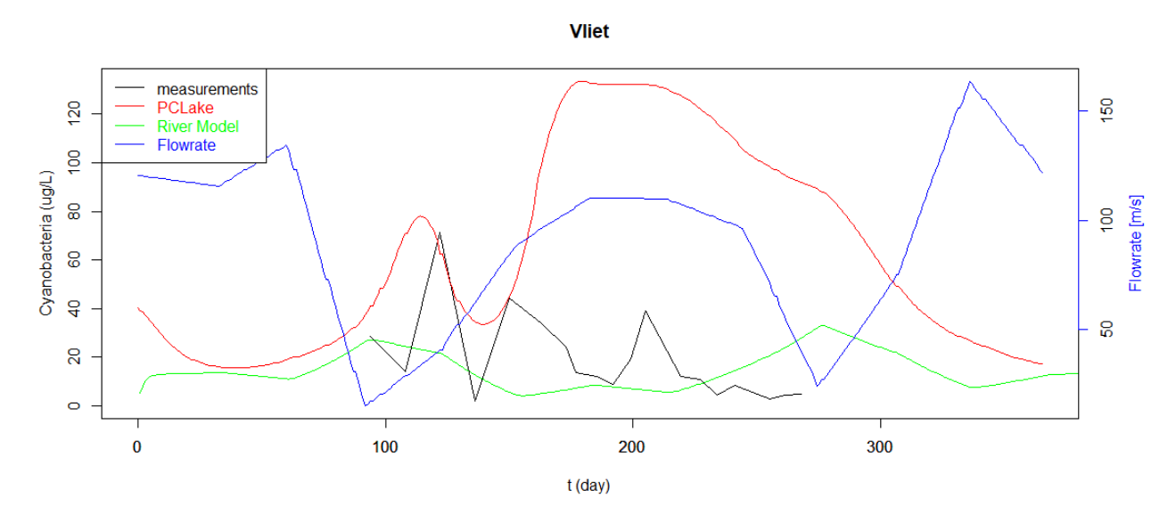

**# Advection & Diffusion (Growth =0, Degradation = 0)**

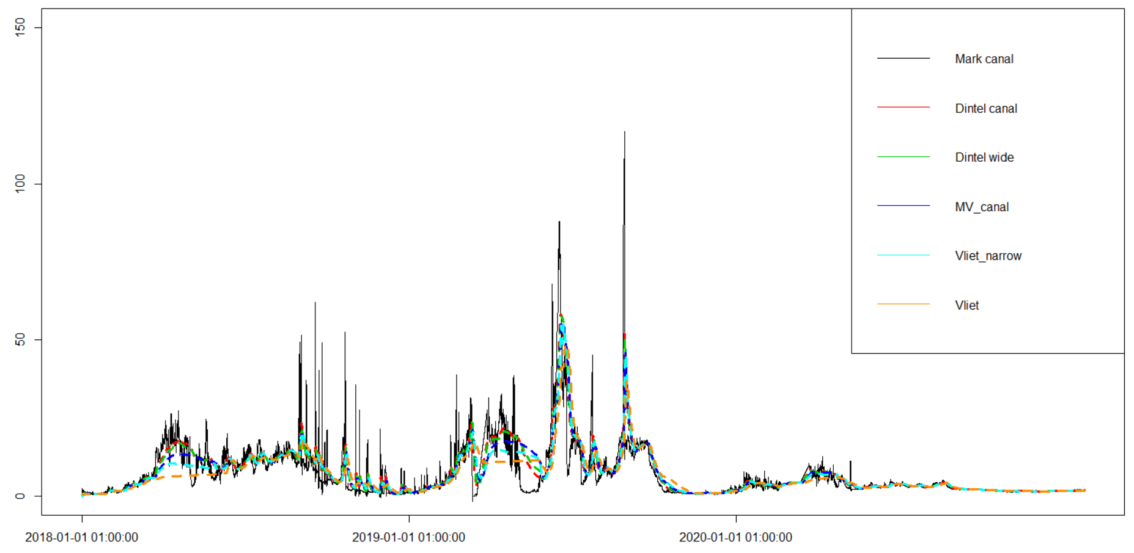

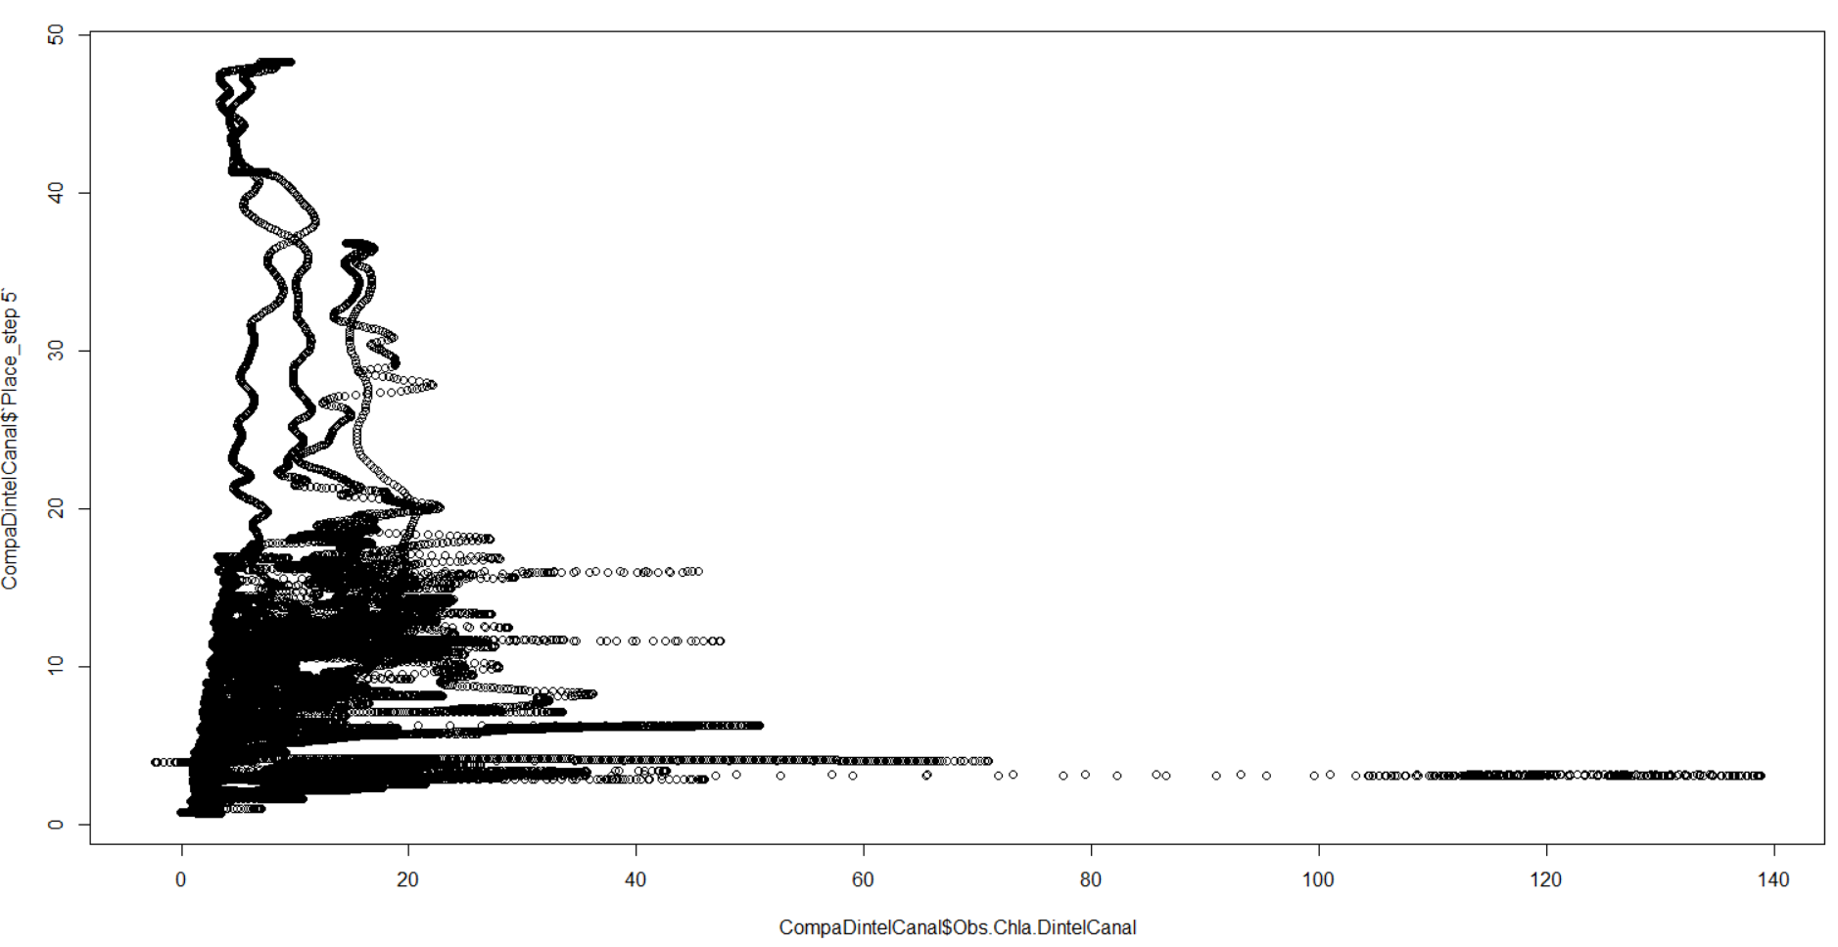

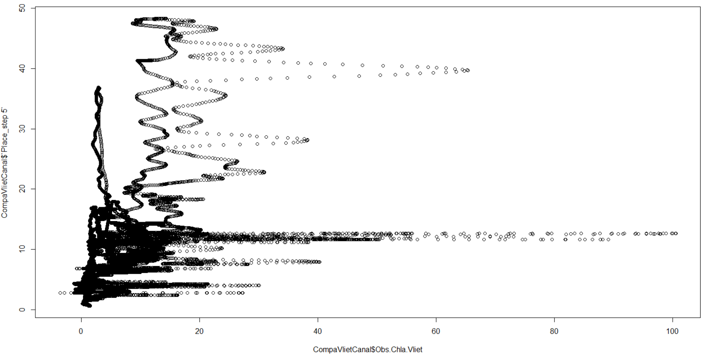

**# Primary production (wDAss – wDRespW – wDLoss – wDMortW)**

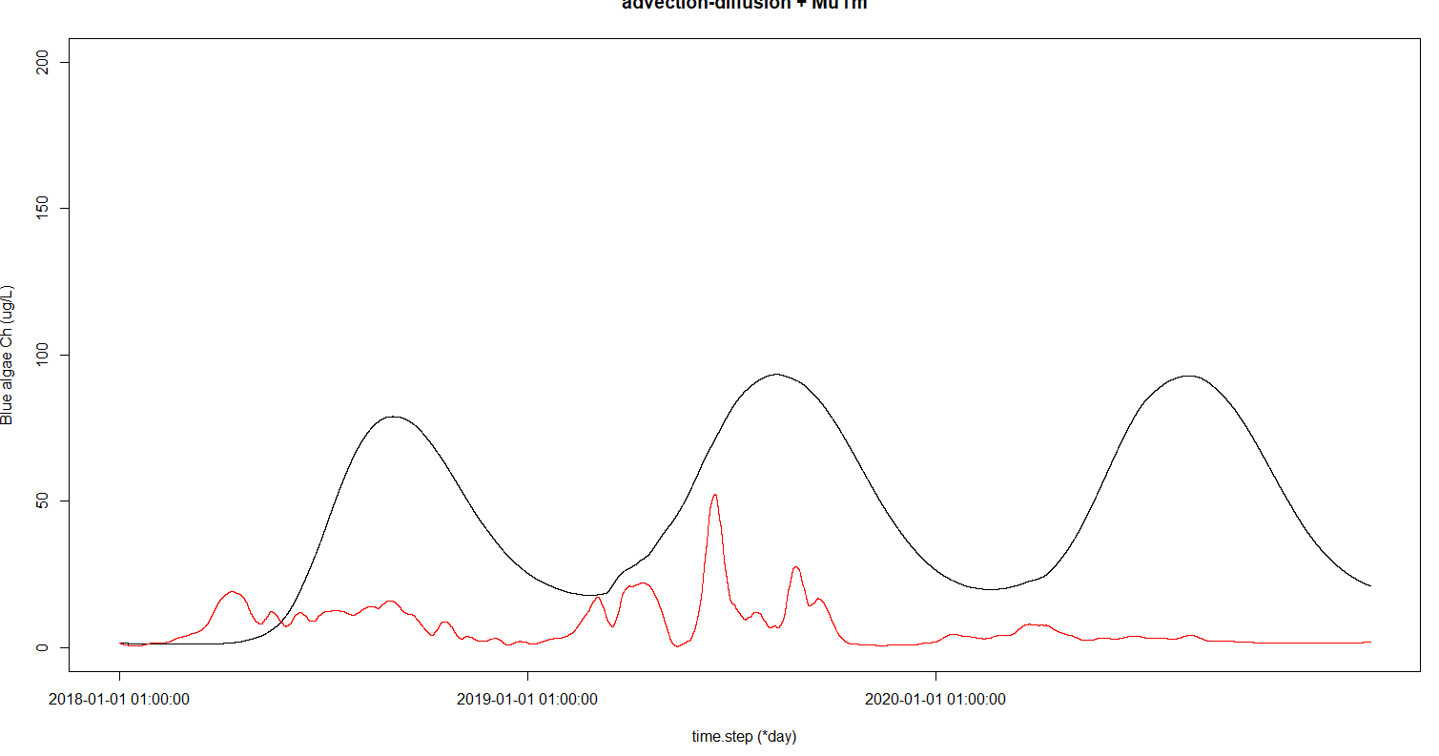

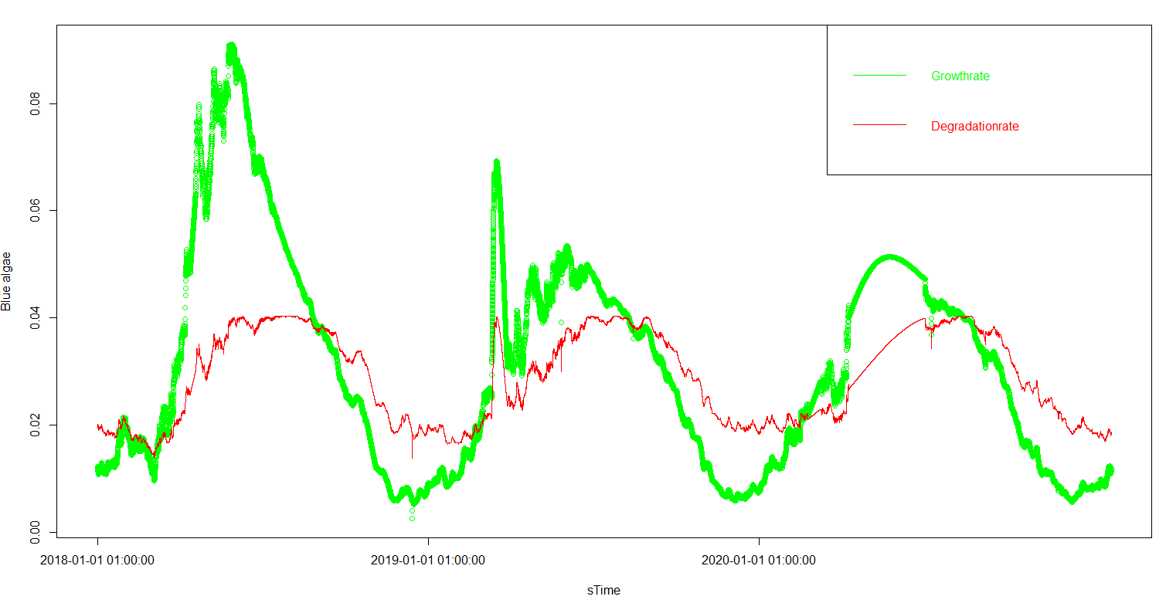

**# Blue alge Chlorophyll_a (Use blue algae parameter set-up and blue algae Chla data)**

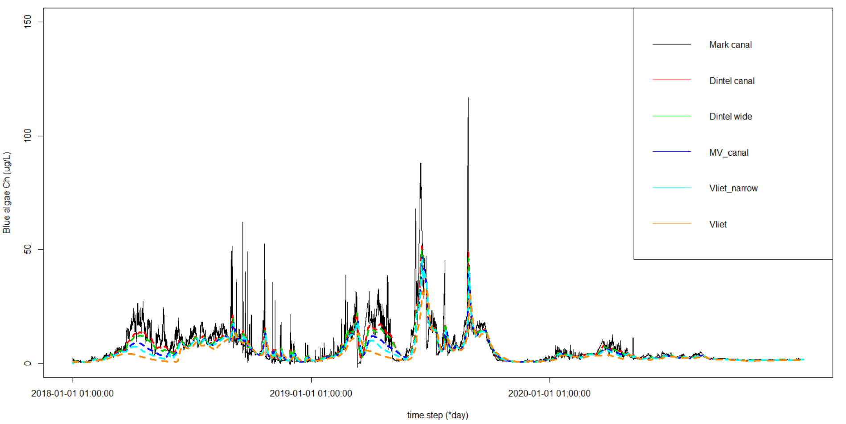

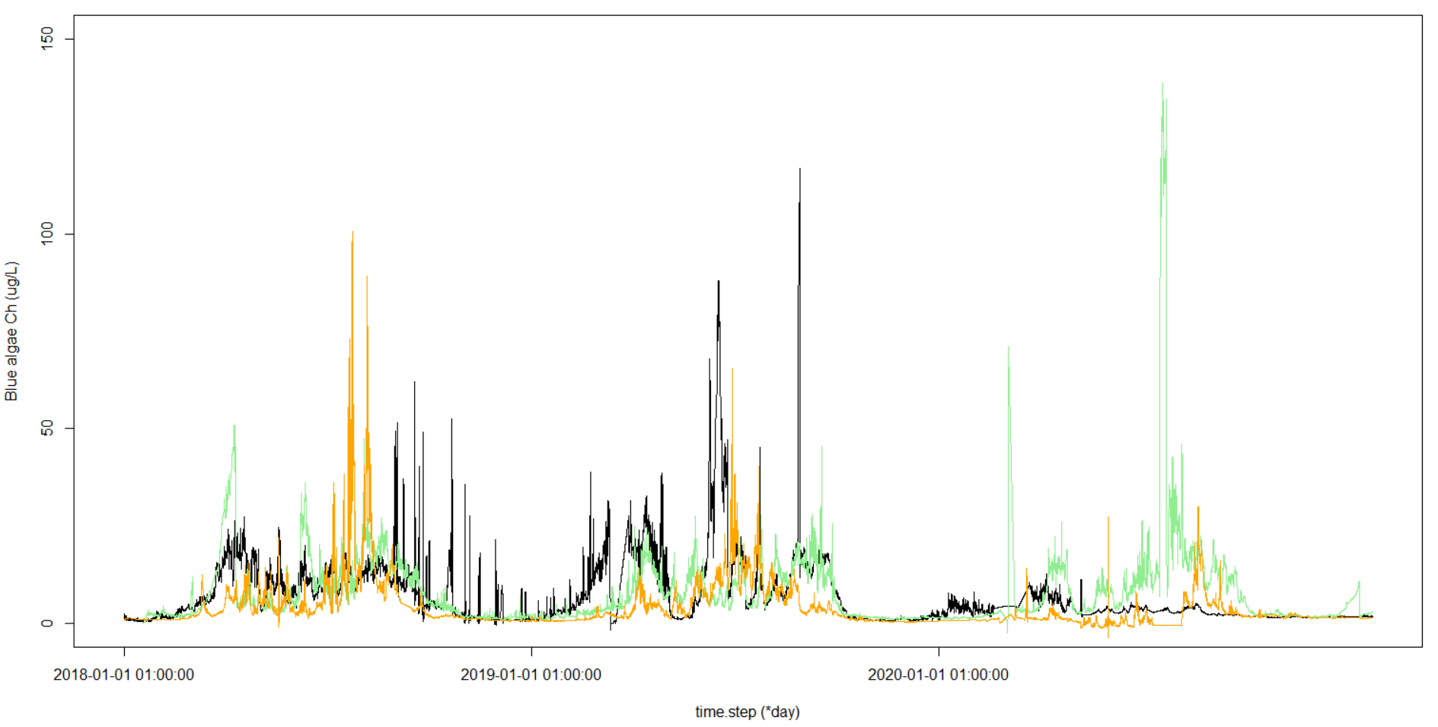

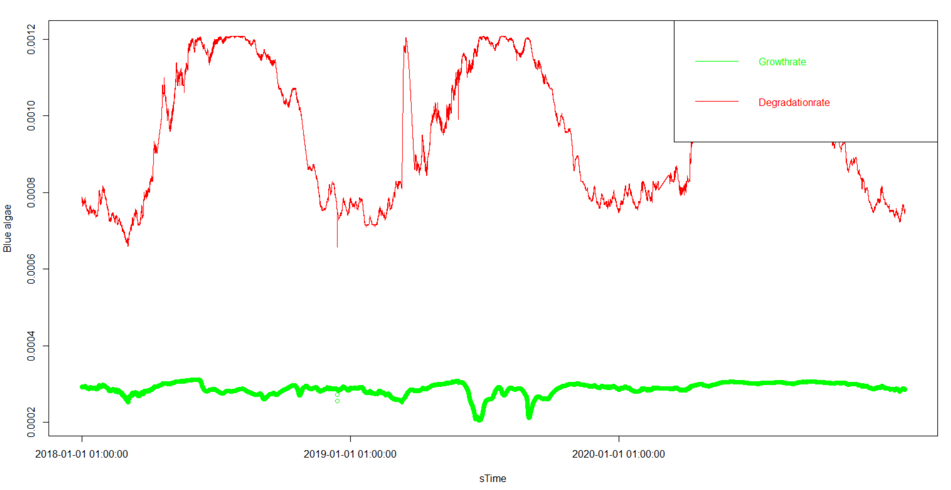

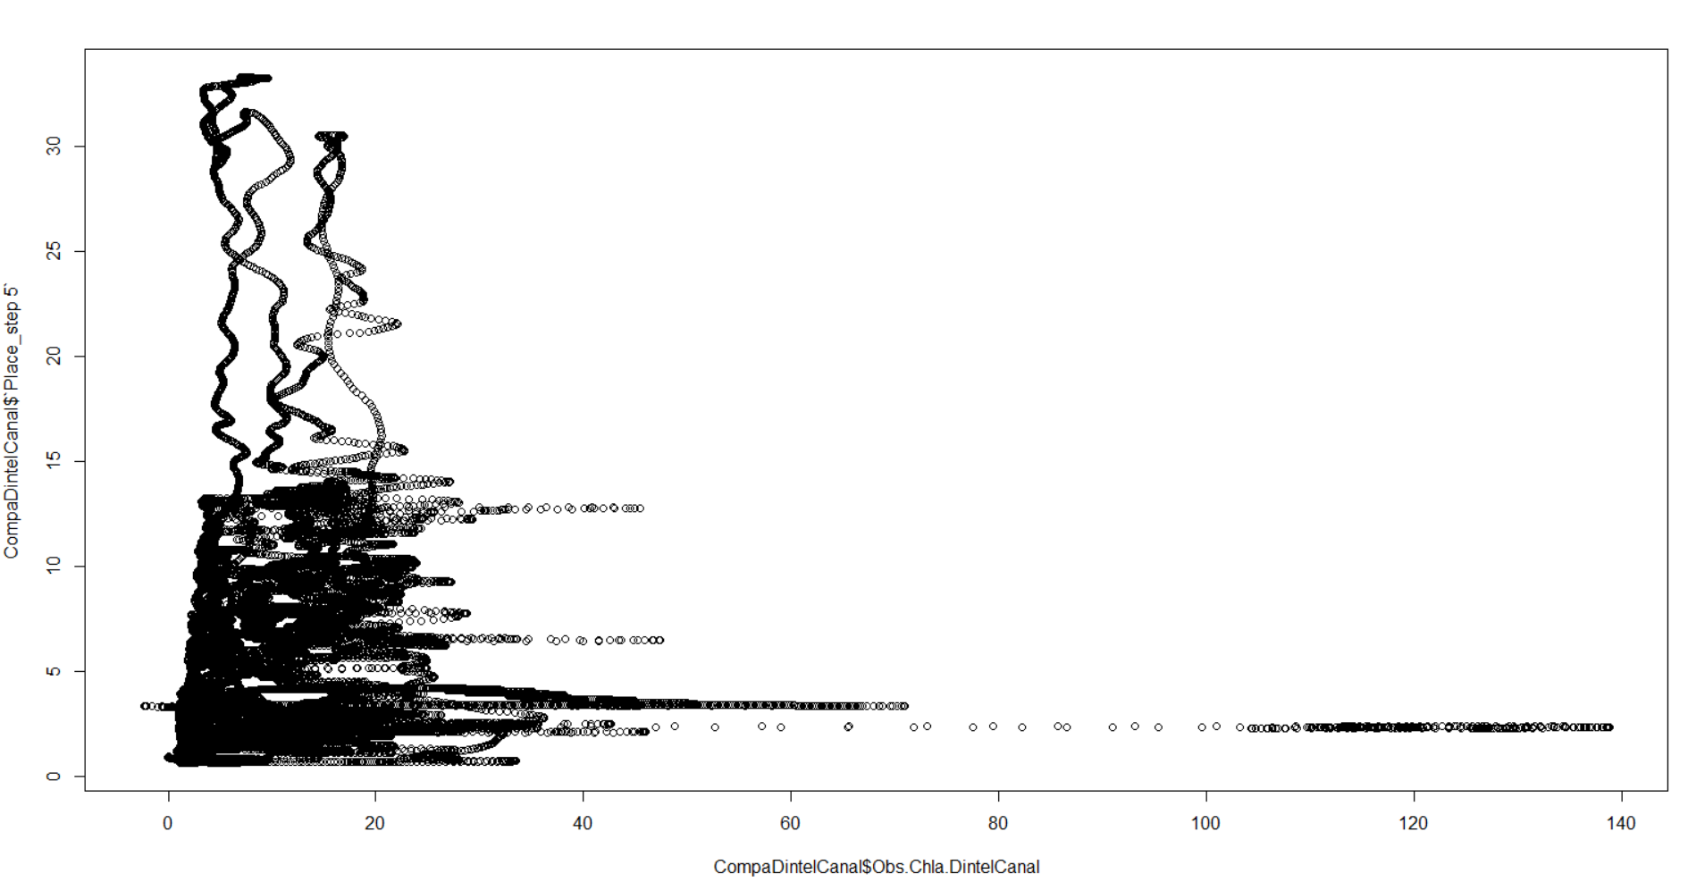

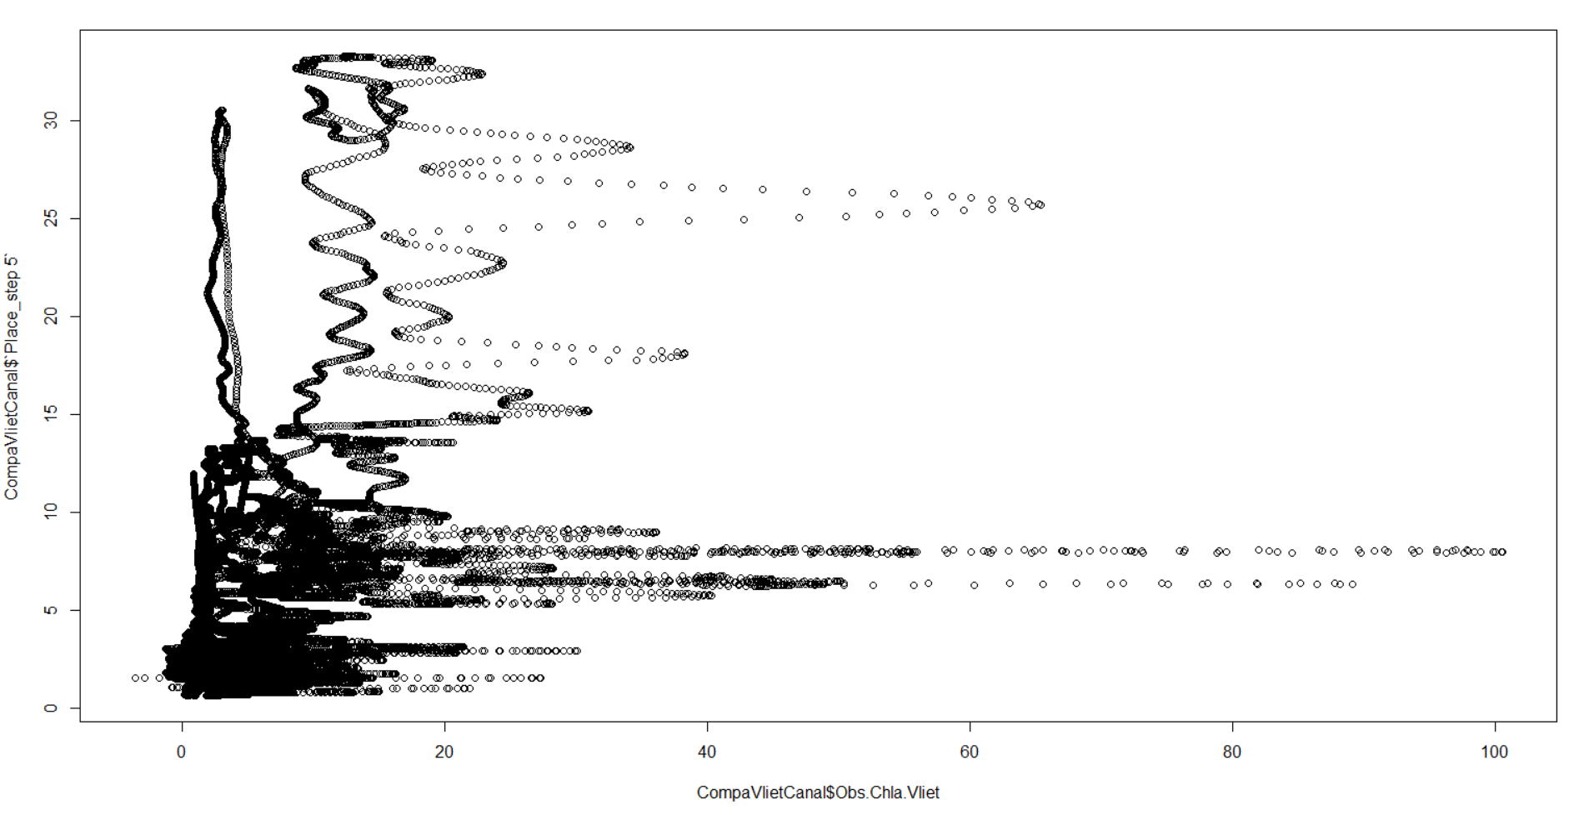

**# Green algae (Use green algae parameter set-up and total Chla data)**

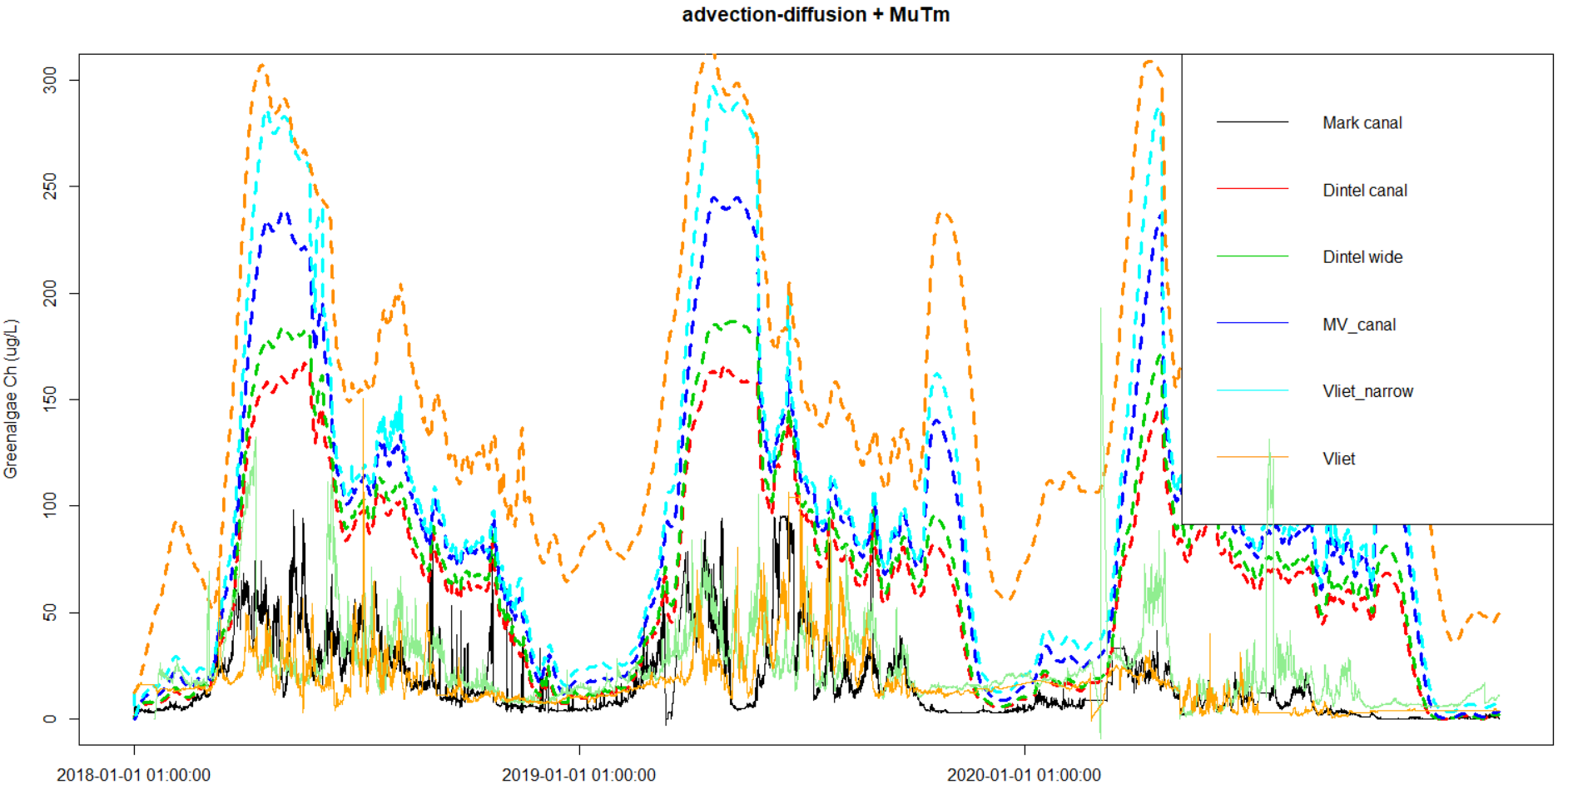

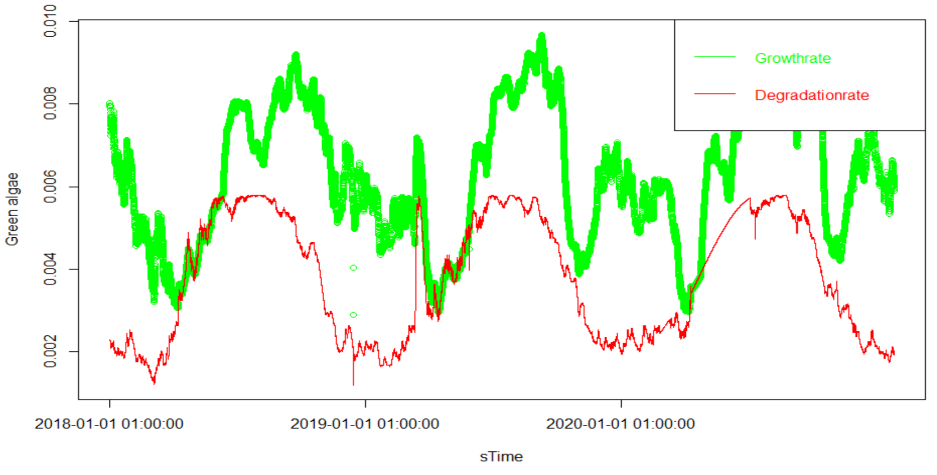

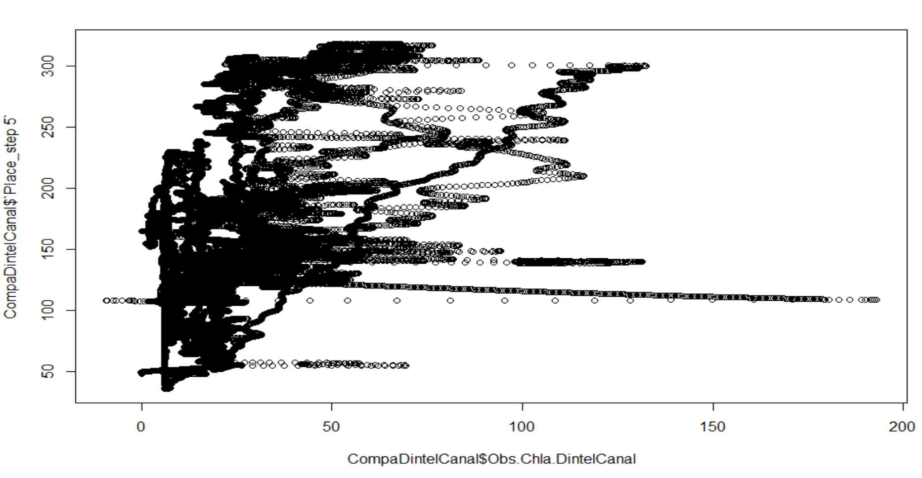

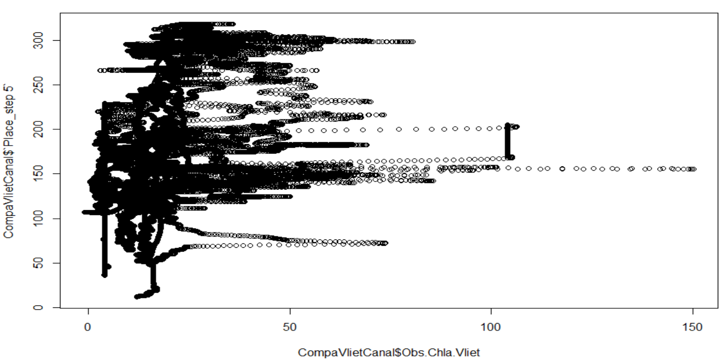

**# Diatom (Use diatom parameter set-up and total Chla data)**

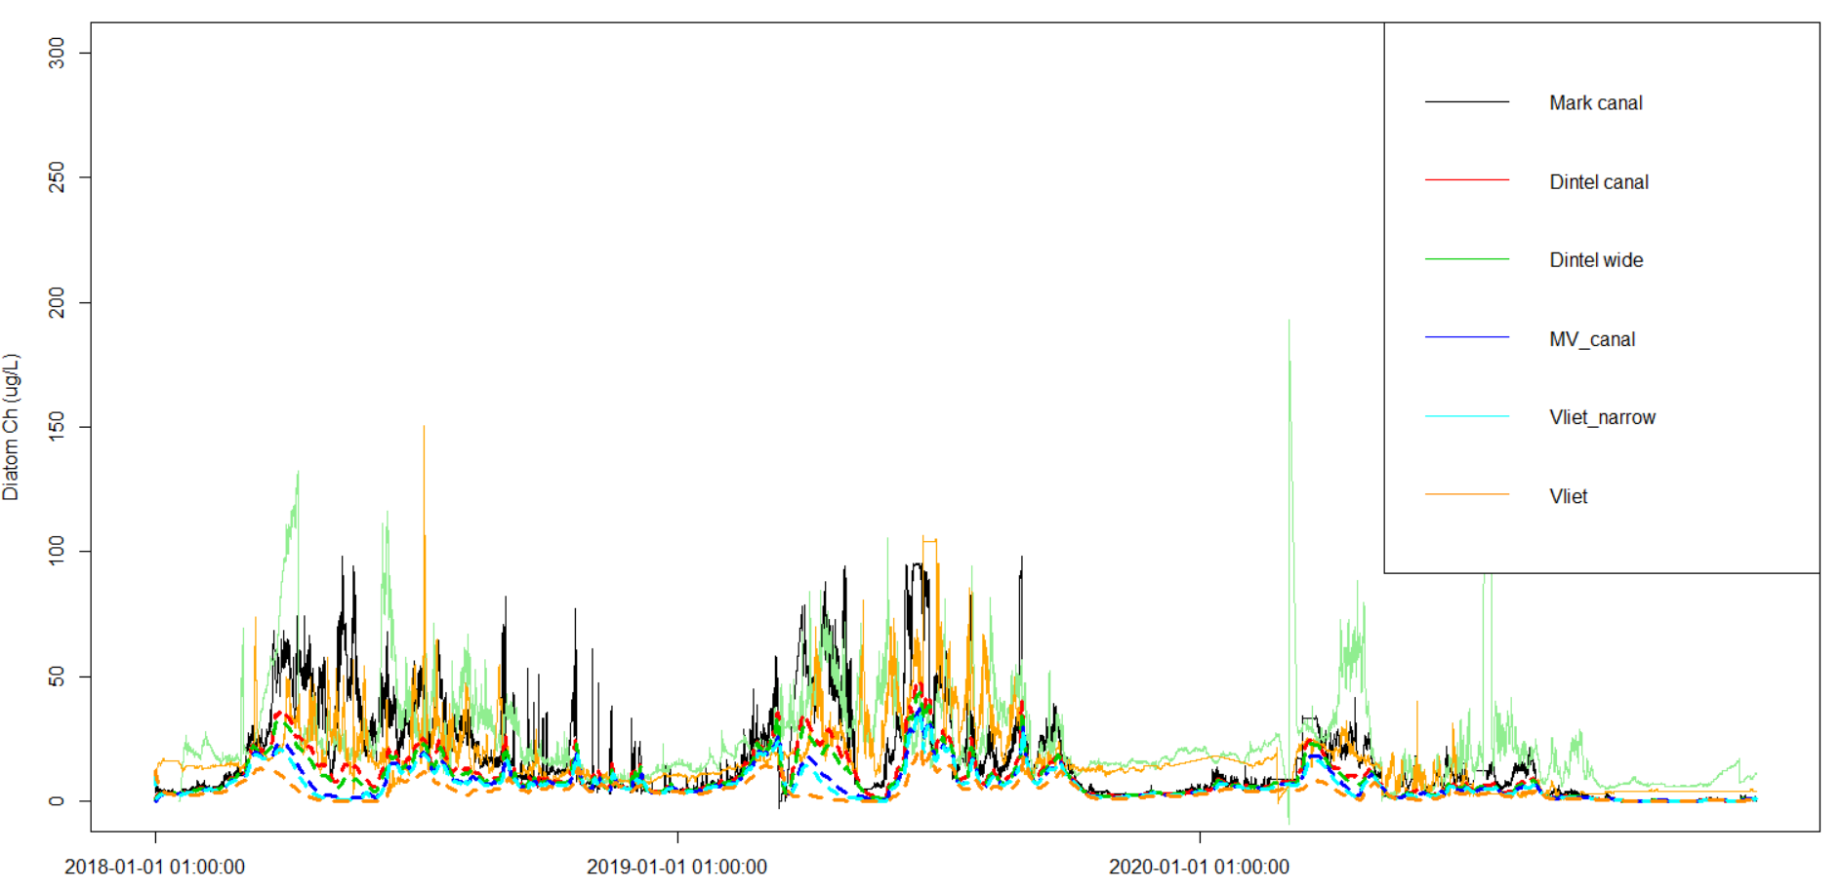

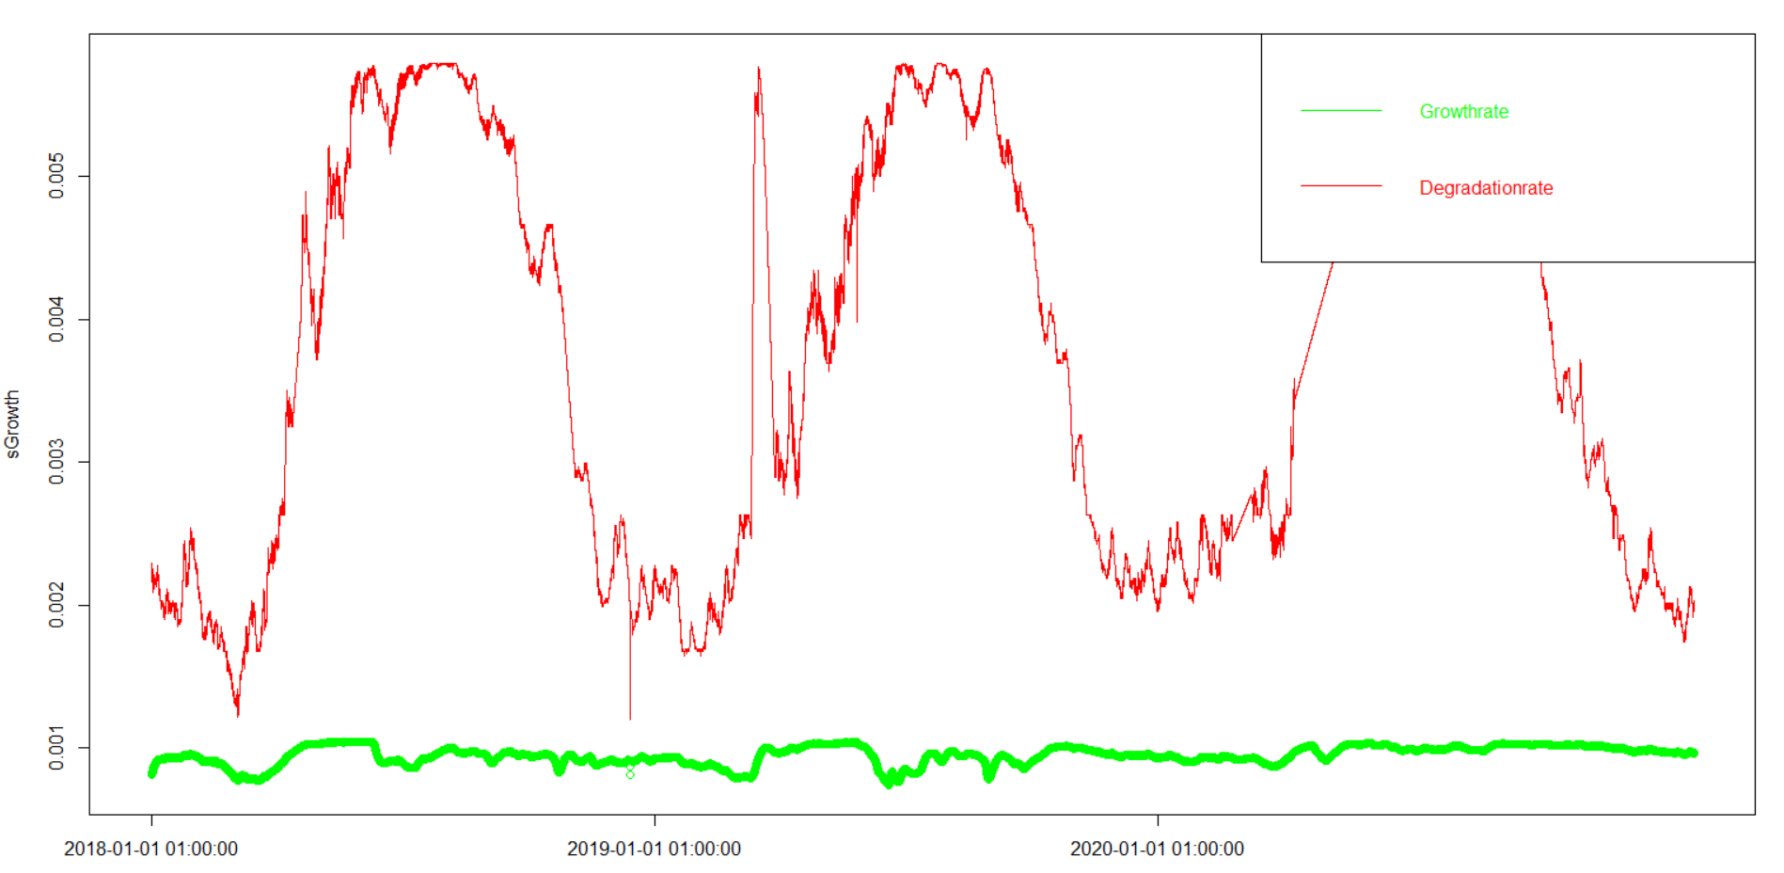

**# C-Q relationship**

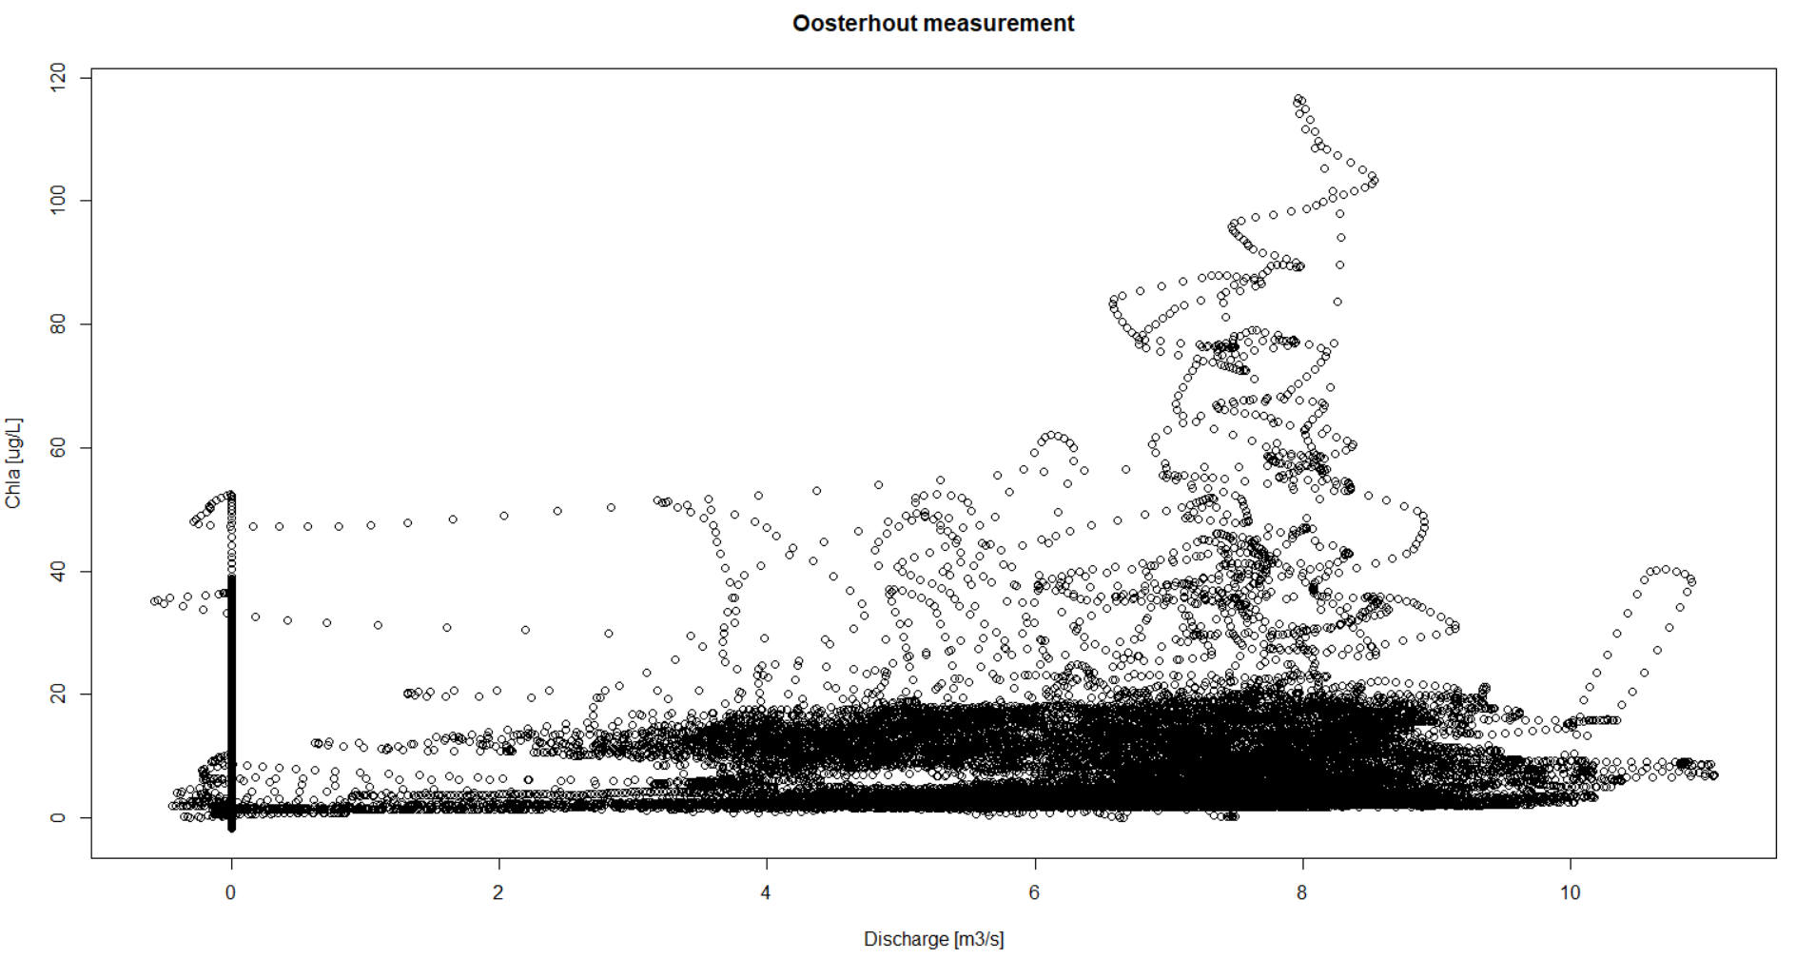

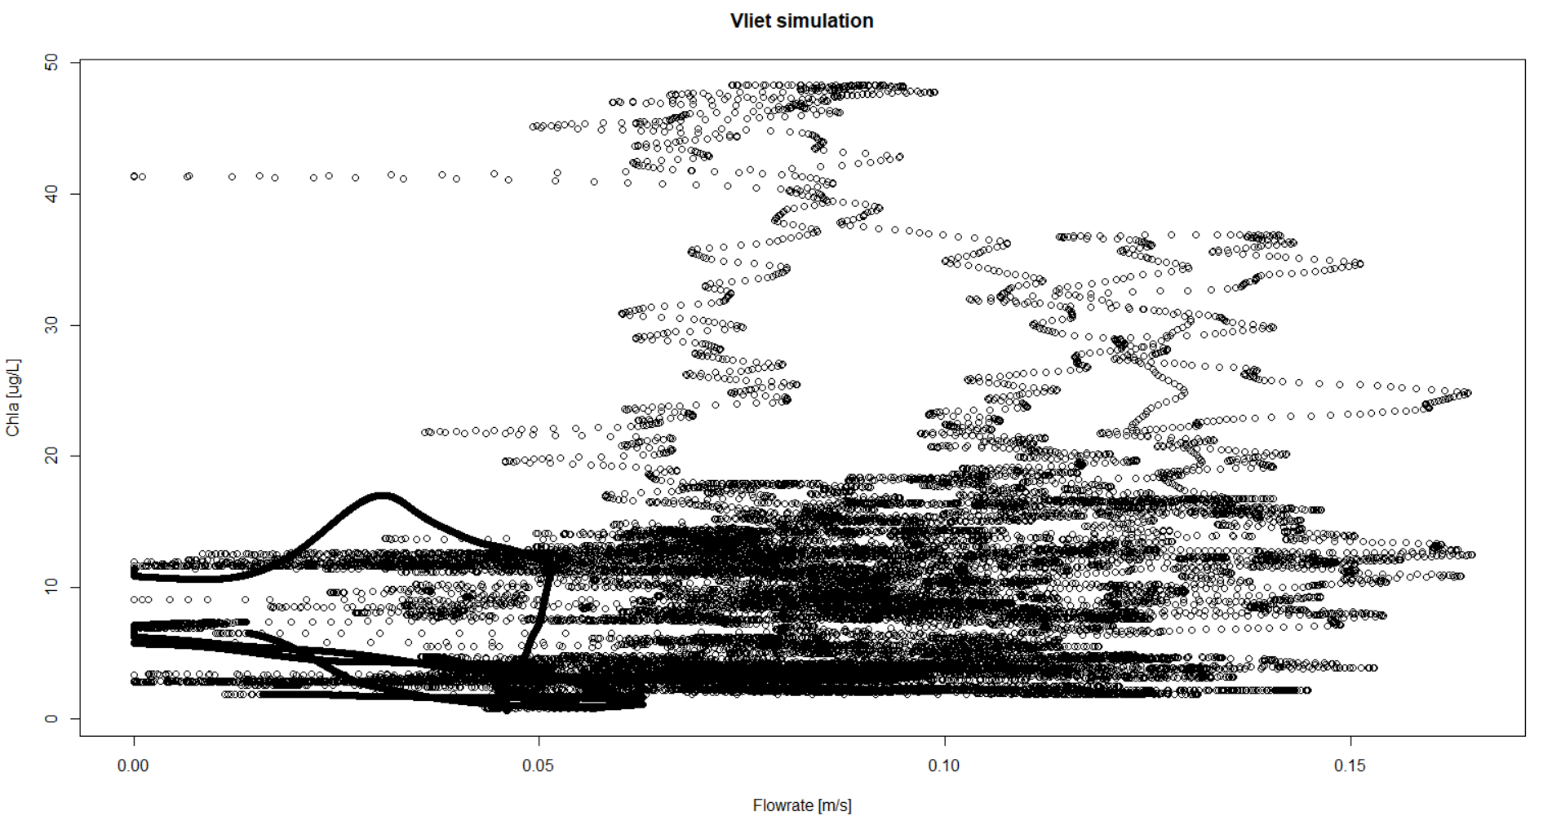

**# measured light intensity from Wageningen weather station**

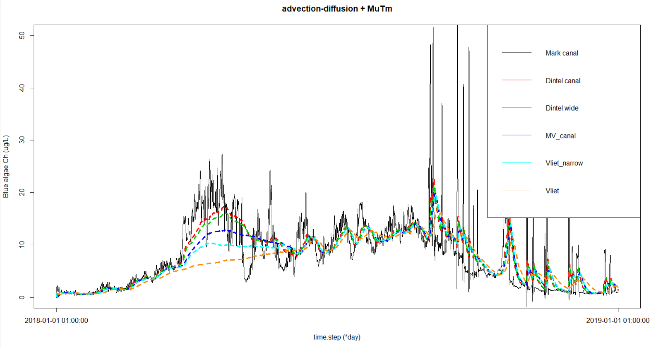

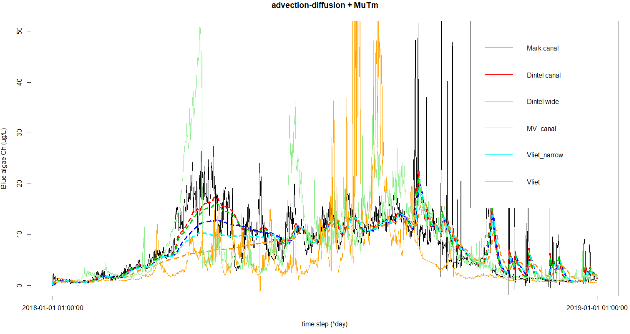

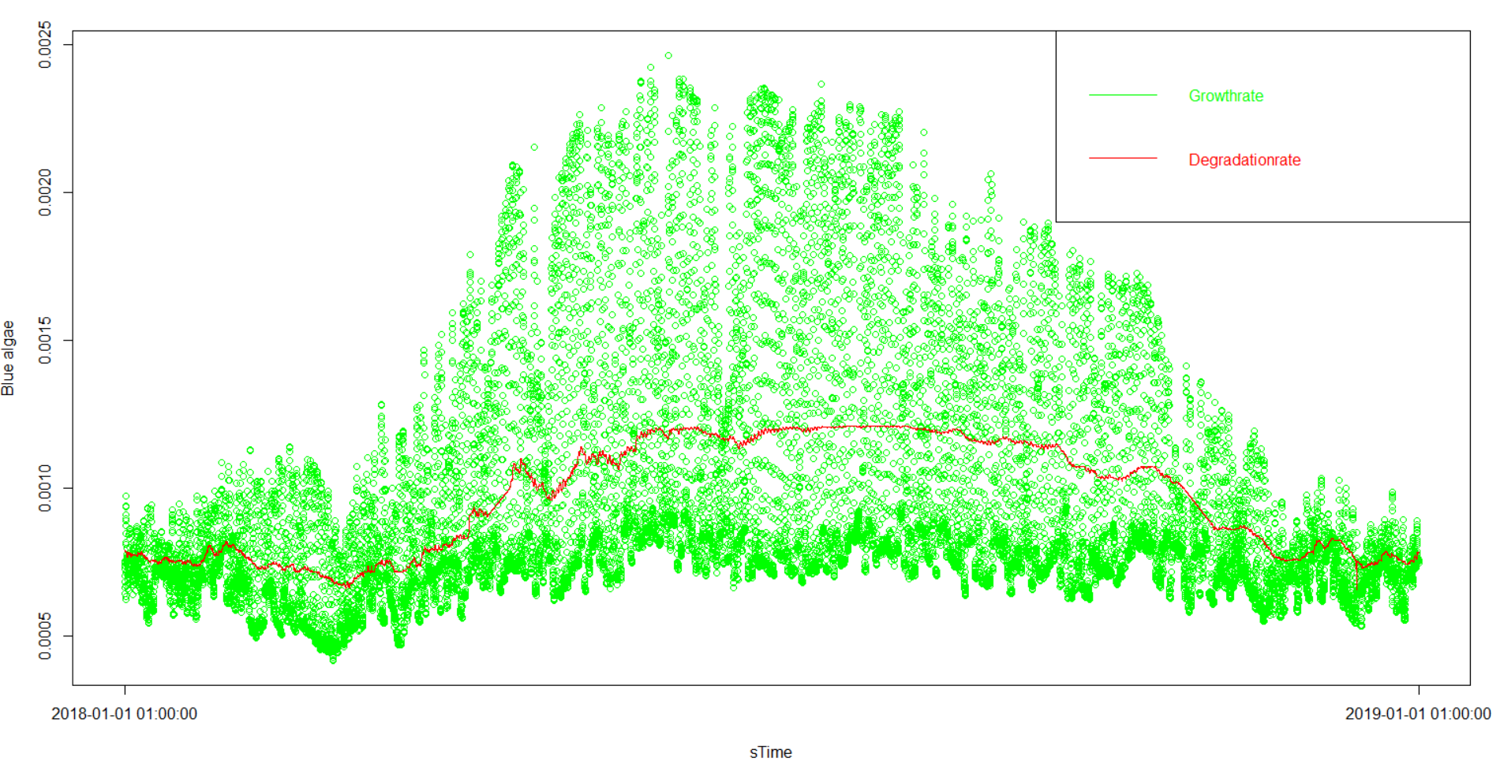

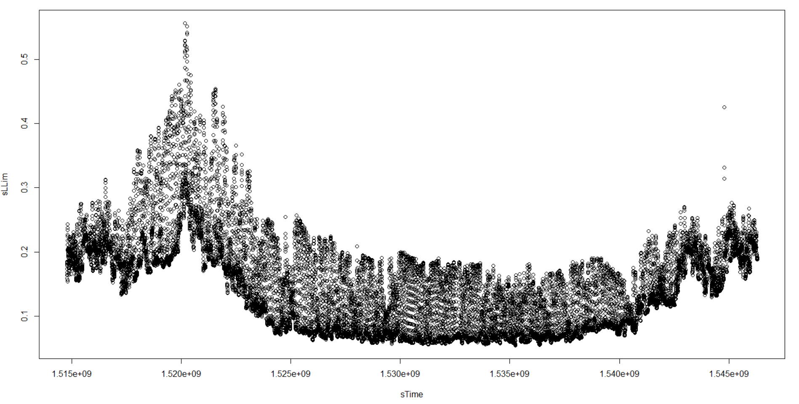

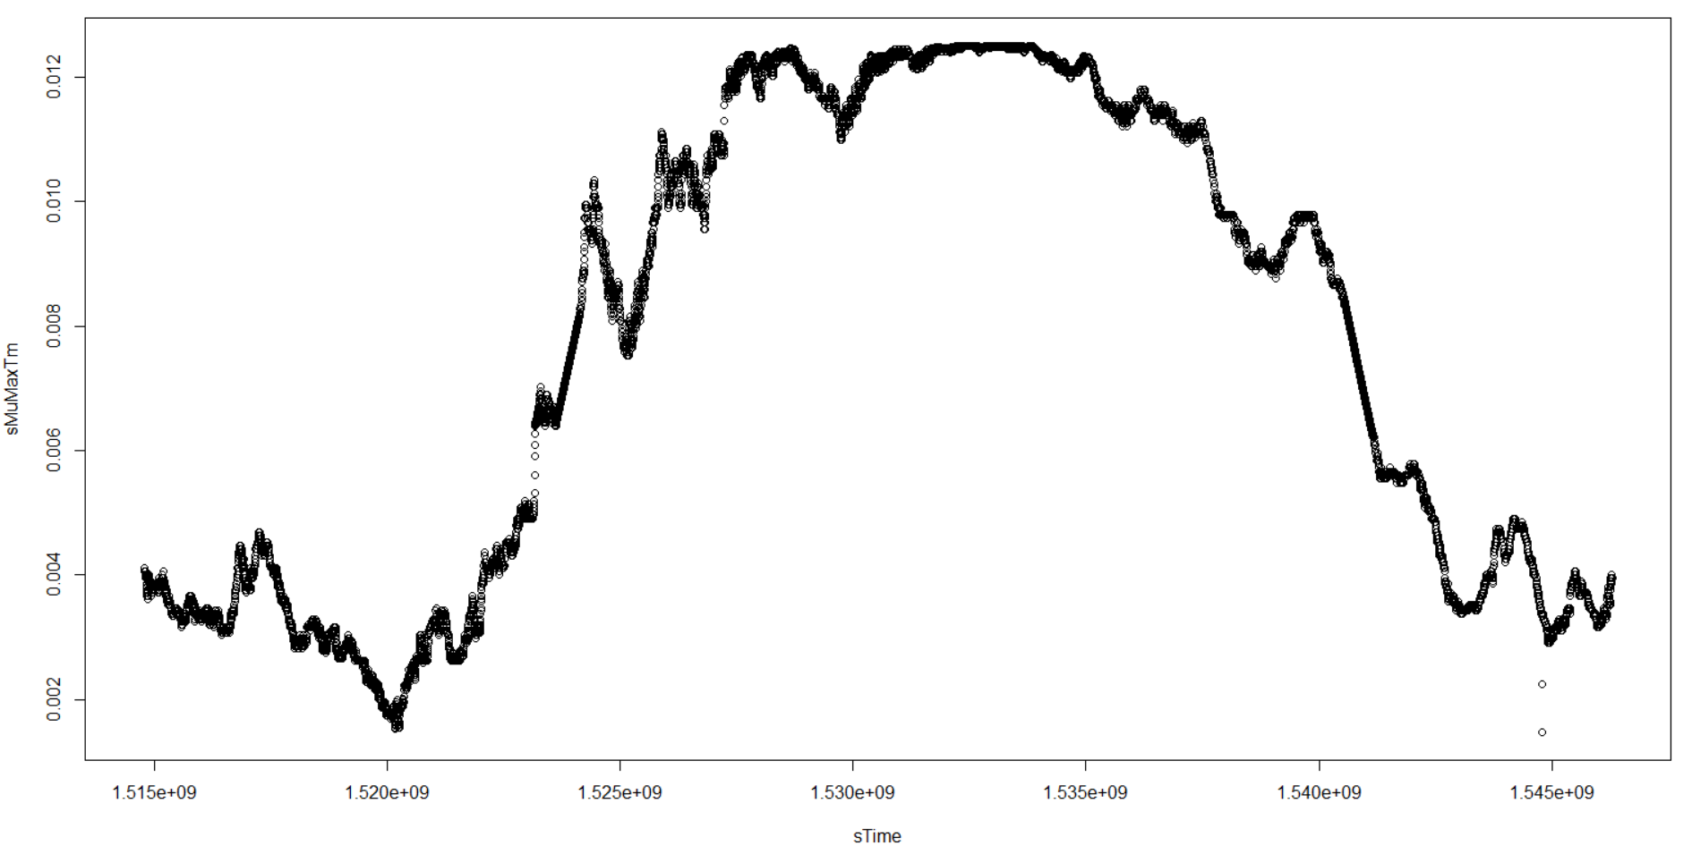

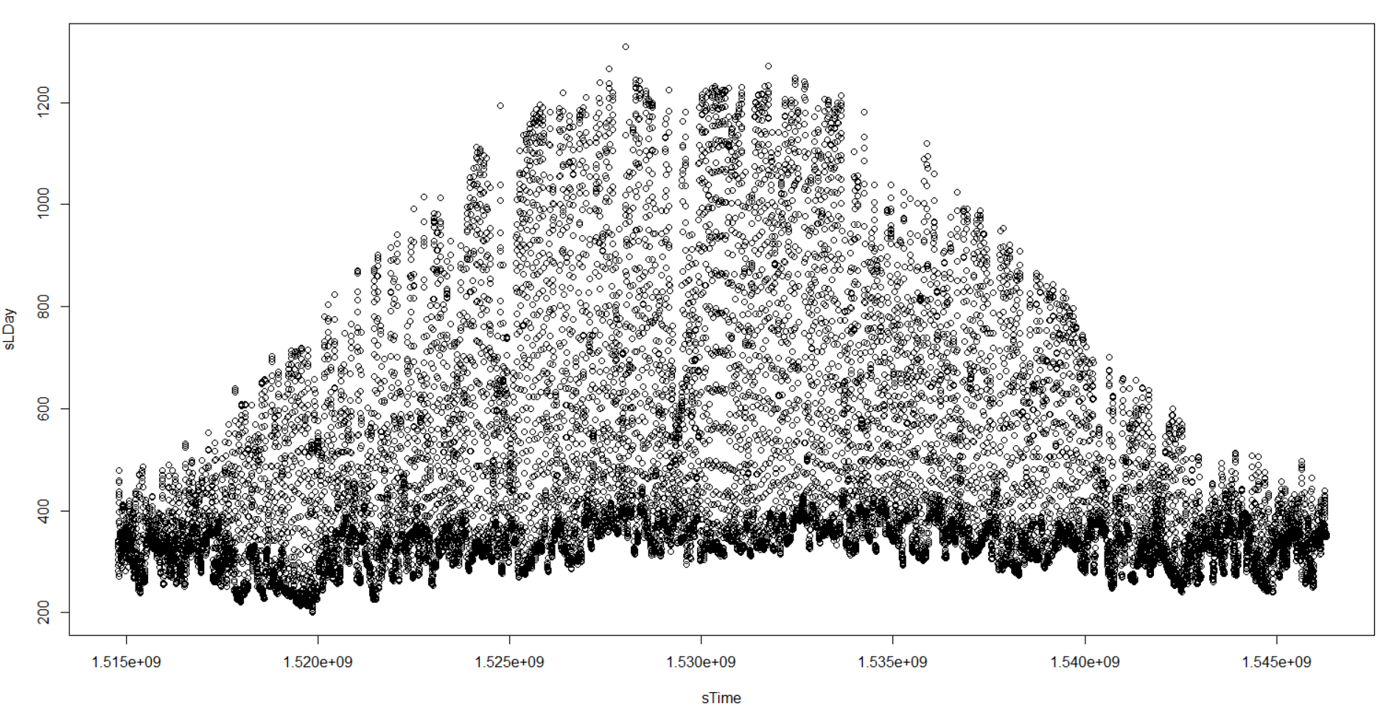

**# Adding nutrients**

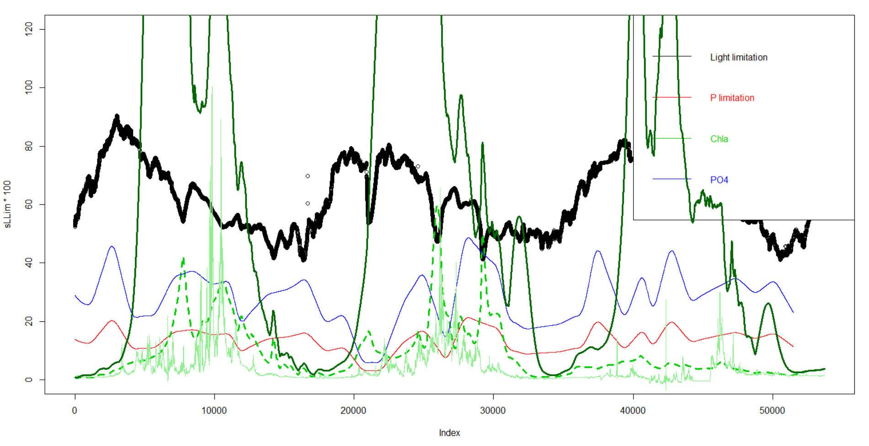

Dark green: aMuTmL = uMuMaxTm*aLLim

Light dashed green: aMuTmL = uMuMaxTm*min(aLLim, aPLim)

Light continuous green: measurements

**# PO4 dynamics**

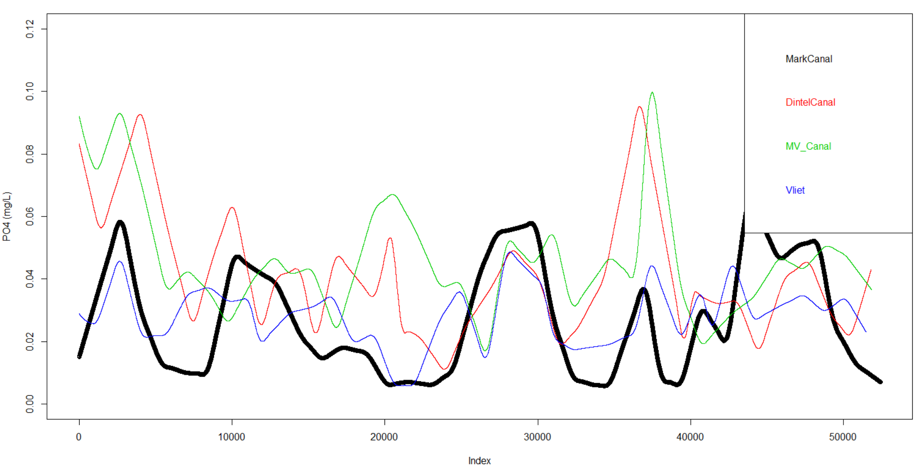

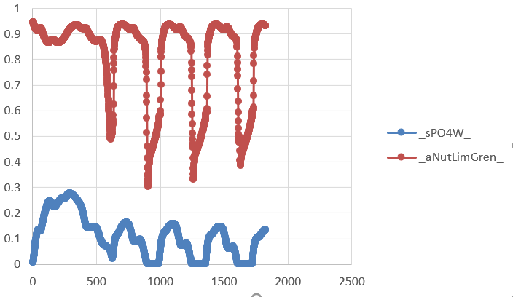

PO4 in water and its corresponding Nutrient limitation by PCLake default parameter set-up

# PCLake simulation with WRT of ca. 1 day

